**Group 3 Homework #2: Data Center Tour Report**

Kevin Yomba, Legendre Cooper, Nathan Ketterlinus, Owen Segala, and Preet Chodavadia

Towson University

COSC 350-001 Data Communications and Networking

Yeong-Tae Song

November 24, 2024

# 

**Introduction:**

Towson University is one of the largest public universities in Maryland, hosting over 20,000 students attending and residing on and off-campus, as well as a number of staff. As with any large public university, Towson relies heavily on the Internet and its supporting technologies to enable its functions as a center of learning and career advancement. Particularly, Towson’s networking technologies have much to do with the quantity and speed that the university systems can store, send, and receive data of all types. On Monday, November 18, students taking Data Communications and Networking under professor Yeong-Tae Song were given the privilege of taking an informative tour of one of the two primary on-site data centers handling the university’s digital information load. Students were divided into groups dedicated to one of each of a number of topics related to the course–this group chose “Networking Technologies”.

This report explores the networking technologies that are implemented at Towson University’s data centers. We will be taking a look at their scalability, reliability, and security. By implementing advanced infrastructure, TU ensures smooth network operations for students, faculty, staff, and visitors. This report will summarize key observations, descriptions of critical equipment, traffic handling, and security techniques that were witnessed during the tour of the data center.

**Summary of Findings:**

TU’s network infrastructure is set up in a way that is appropriate for the needs of its users, adaptive to varying network conditions, and scalable as the campus grows. It has many features that showcase this, such as:

* Two data centers are strategically positioned on campus.
* Two category 7 (10 Gbps) fiber optic cables connect them.
  + Uses Cisco’s proprietary Hot Standby Router Protocol (HSRP) protocol.
* Redundant data storage between the two data centers.
  + Storage measured in Petabytes!
* Double offsite storage for critical components.
* F5 load balancers in both data centers.
* Redundancy in cooling technologies
  + Ambient cooling
  + In-rack cooling through Opticool
* ~1.5 Tb of available RAM in Data Centers
* VMware virtualization in Data Centers
  + ~150 concurrent VMs running at any given time

These features allow TU to have a sophisticated cross-campus network perfect for students, faculty, staff, and visitors. Its ISP is MDRan, which belongs to the USM entity (a tier 2 ISP). Because it is encapsulated as such, USM can intercept and forward all traffic for universities in the state of MD to the relevant university, further improving security and efficiency.

As for Group 3’s topic of networking technologies, we identified a few key characteristics. As mentioned above, the campus infrastructure revolves around two data centers: a primary in the student union, and an auxiliary in Cook Library. These data centers are directly linked via two underground Cat 7 cables, capable of a combined 20 Gbps of throughput. All wifi-enabled buildings on campus then directly connect to these Cat 7 cables through their Building Hub. These Building Hubs receive traffic from multiple Network Rooms in the building via RJ45 copper ethernet cables. Finally, users can connect to these Network Rooms wirelessly by interfacing with one of several wireless access points around campus. This layout can be conceptualized as follows:

* **Access Layer**: Hub rooms in buildings.
* **Distribution Layer**: Centralized building connections.
* **Core Layer**: The data centers themselves.

The complete relationship is diagrammed below for a more concise explanation.

**List of Equipment with Specification:**

All networking equipment is Cisco-branded. Equipment covered during the tour includes:

* Cat 7 Ethernet cables: These are high-performance cables supporting 10 Gbps for inter-data center connections.
* RJ45 copper ethernet cables: These connect the hub rooms within the building to the network rooms.
* F5 load balancers: These distribute traffic across servers and provide additional security.
* Opticool in-rack cooling: A chilled water system that maintains optimal server temperatures.
* Fire Suppression Systems: There is both a chemical and water-based system to prevent fire damage and water damage to the servers.
* VMware virtual machines: They run approximately 150 VMs to make sure resources are utilized efficiently.
* Microsoft Azure off-site hosting: This hosting provides an offsite backup of key services.
* Wireless Access Points: These provide wireless access in buildings across campus.

While not necessarily Equipment, the data center also features:

* A “dirty room” to process all incoming equipment
* A “clean room” where everything is actively running
* ID verification to get through both doors
  + An alarm on the door goes off if open for too long
* Duct Tape floors are replaced every other day to remove dirt and grime from shoes

**Diagram for the equipment location and used technology:**

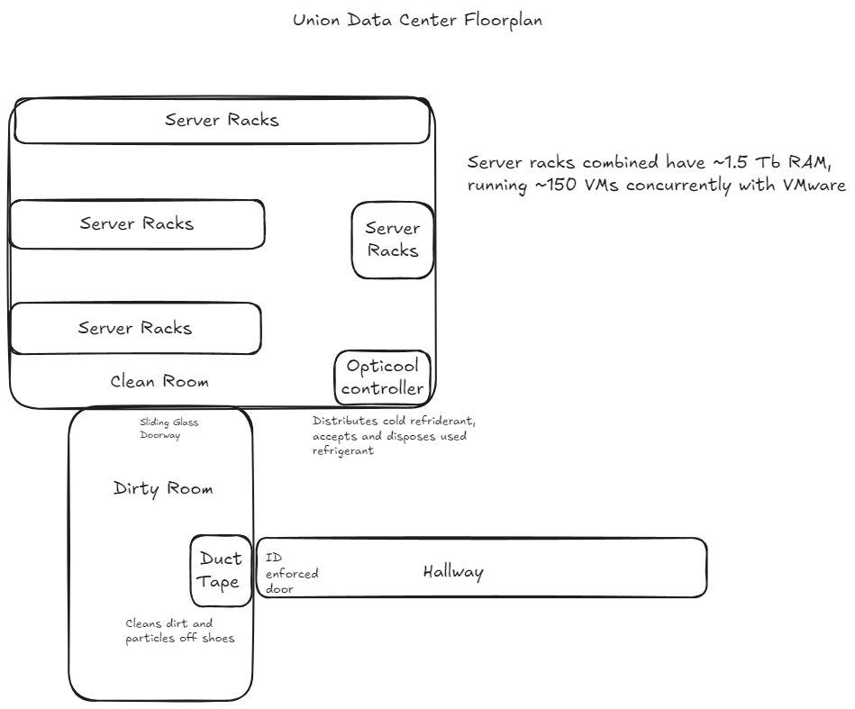

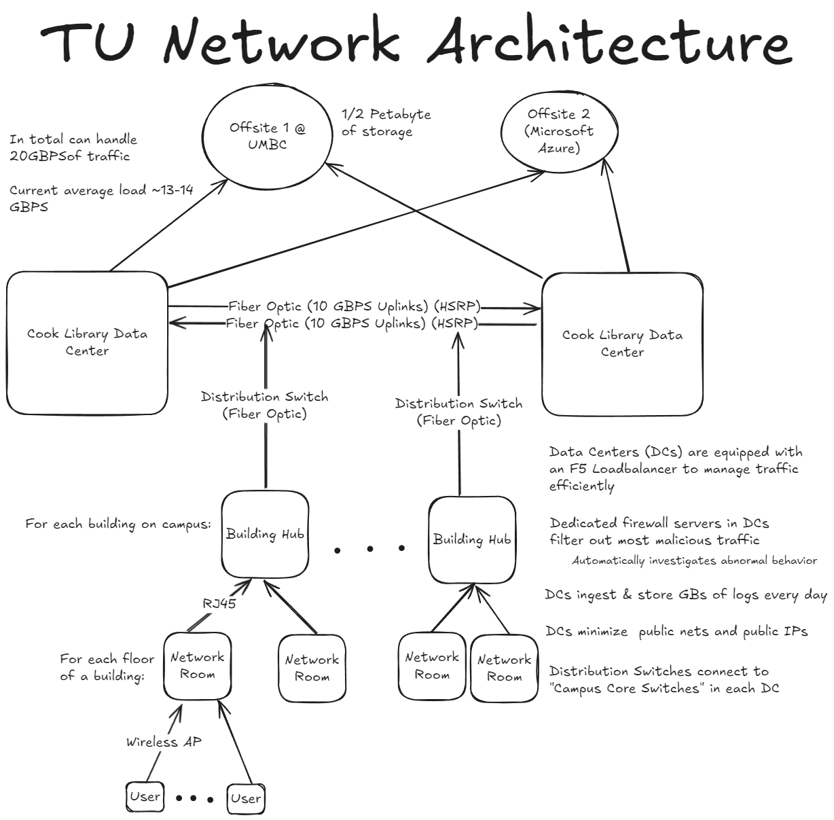

Example of a packet from the internet traveling to a TU user:

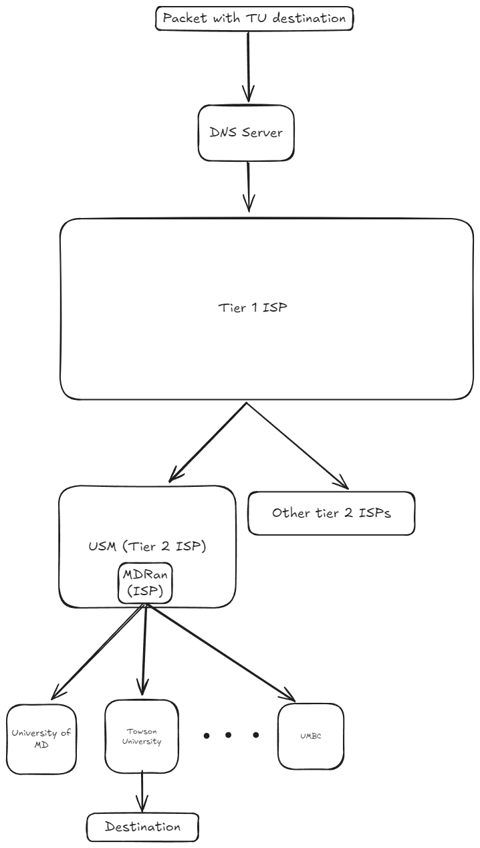

**Storage and web server – equipment and IP addressing scheme (e.g., how to handle large network traffic), security-related techniques (how it works):**

The data center at the union is equipped with towers containing hundreds of terabytes of storage to accommodate extensive data requirements. However, they are transitioning towards a more web-server and cloud-based infrastructure, particularly for off-campus data centers, utilizing Microsoft Azure. To ensure continuity of critical services, they maintain a secondary on-campus data center as a backup for on-campus users. In the rare event of a complete campus data center outage, two offsite data centers—one located at UMBC—are prepared to take over critical services.

Towson University oversees a total of 21,504 IPv4 addresses across three main IP ranges.

* - 136.160.128.0 / 18 (16,384 addresses)
* - 204.62.32.0 / 20 (4,096 addresses)
* - 204.62.48.0 / 22 (1,024 addresses).

Most end user-stations use private IP addresses which must be mapped to some public IP address to communicate outside their LAN environment. Incoming traffic is sent to the correct destination via suffix bytes that determine the correct local network and host through subnetting. These techniques let TU provide enough IP addresses for everyone in the university, with a comfortable buffer in times of increased demand.

The data center employs load balancers to distribute network requests evenly across servers, enabling efficient handling of large traffic volumes. With a 20G fiber connection, their bandwidth capacity is significant, and daily usage rarely exceeds half of its potential, providing ample room for growth. To stay ahead of future demands, the team proactively plans upgrades for 5–10 years and replaces hardware on a six-year cycle.

Security is a top priority, with dedicated firewall towers in place to manage and enforce stringent security protocols. The team also actively monitors bandwidth usage, immediately investigating any unusual or excessive activity to ensure network integrity and prevent misuse.

**Ethernet and Cabling**

The secondary data center at Towson emphasizes robust Ethernet and cabling solutions to ensure reliable network connectivity across the campus. All buildings connect to the data centers via underground fiber optics, with every building featuring a dedicated network hub room. These hubs link to the data centers through distribution switches, ensuring consistent high-speed access via RGA45 copper Ethernet cables. Each data hub has dual connections to both data centers, enhancing network reliability and throughput.

### **Network Redundancy and Failover**

Redundancy is a cornerstone of the data center's design, providing seamless failover capabilities. If one data center experiences a failure, the other can sustain campus operations at up to 10Gbps speed. This setup minimizes service disruption, with systems like SQL databases designed with high redundancy. Critical services also utilize offsite backups hosted on Microsoft Azure and the University of Maryland, Baltimore County (UMBC), further strengthening disaster recovery options.

**Network Security**

Towson's network security strategy includes multiple layers of defense. All devices connecting to the network require MAC address registration, and abnormal bandwidth usage triggers automatic investigations. Dedicated firewall servers protect the campus's data, while public-facing IPs are minimized to reduce exposure. The "F5" load balancers, one at each data center, provide not only traffic distribution but also function as advanced security devices to handle potentially malicious traffic.

**Wi-Fi**

The campus Wi-Fi network benefits from the robust infrastructure provided by the secondary data center. Each building’s network hub connects directly to both data centers, ensuring stable and high-speed wireless coverage across the campus. With a central distribution network in place, bandwidth flexibility and optimal usage are maintained, even during peak periods.

**Data Transmission and Latency**

Towson's secondary data center supports a campus-wide network with a total bandwidth capacity of 20Gbps, split across two 10 Gbps uplinks. This high-capacity setup ensures minimal latency and efficient data transmission. The Layer 2 network architecture allows the data centers to function as though they are in the same physical location, enhancing performance and reducing delay.

**Network Monitoring**

Monitoring is a continuous process, with monthly architecture reviews and audits conducted to ensure optimal performance. The data center ingests gigabytes of logs daily, helping to identify and address potential issues quickly. Abnormal traffic or bandwidth consumption is flagged for immediate investigation, ensuring network reliability and security.

**Cooling**

The data center utilizes advanced cooling systems, including in-rack cooling (OptiCool) and ambient air systems, to maintain optimal operating temperatures. The OptiCool system uses a chilled water refrigerant line to exchange heat with the server racks. These efficient cooling solutions are critical for preventing overheating, as the hardware generates significant heat proportional to the power used.

**Future-Proofing and Scalability**

Planning for future upgrades is integral to Towson’s strategy. The data center hardware undergoes a replacement cycle every six years, and plans for upgrades extend 5–10 years ahead. As technology evolves, the center is transitioning from VMware to Microsoft's virtualization software and is increasingly shifting workloads to the cloud. This approach ensures scalability and keeps the infrastructure aligned with modern demands.